Laboratory Exercise 5

Character string with SYSCALL function, and sorting

**Assignment 1:**

MIPS:



Kết quả:



* Câu lệnh la tách làm 2 câu lệnh lui và ori.

**Assignment 2:**



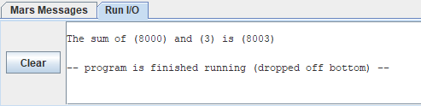

**Assignment 3:**

#Laboratory Exercise 5**,** Home Assignment 2

.data

y**:** .asciiz "Hello" # source string y

x**:** .space 1000 # destination string x**,** empty

**.text**

la $a1**,** y

la $a0**,** x

strcpy**:**

**add** $s0**,**$zero**,**$zero #s0 **=** i**=**0

L1**:**

**add** $t1**,**$s0**,**$a1 #t1 **=** s0 **+** a1 **=** i **+** y**[**0**]**

# **=** address of y**[**i**]**

lb $t2**,**0**(**$t1**)** #t2 **=** value at t1 **=** y**[**i**]**

**add** $t3**,**$s0**,**$a0 #t3 **=** s0 **+** a0 **=** i **+** x**[**0**]**

# **=** address of x**[**i**]**

sb $t2**,**0**(**$t3**)** #x**[**i**]=** t2 **=** y**[**i**]**

beq $t2**,**$zero**,**end_of_strcpy #if y**[**i**]==**0**,** exit

**nop**

addi $s0**,**$s0**,**1 #s0**=**s0 **+** 1 **<->** i**=**i**+**1

j L1 #next character

**nop**

end_of_strcpy**:**

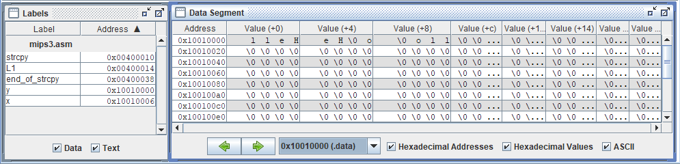

**Assignment 4:**

#Laboratory Exercise 5**,** Home Assignment 3

.data

string**:** .space 50

Message1**:** .asciiz "Nhap xau:"

Message2**:** .asciiz "Do dai la "

**.text**

main**:**

get_string**:**

la $a0**,** Message1

la $a1**,** string

la $a2**,** 49

li $v0**,** 54

**syscall**

get_length**:**

la $a0**,** string # a0 **=** Address**(**string**[**0**])**

**xor** $v0**,** $zero**,** $zero # v0 **=** length **=** 0

**xor** $t0**,** $zero**,** $zero # t0 **=** i **=** 0

check_char**:**

**add** $t1**,** $a0**,** $t0 # t1 **=** a0 **+** t0

#**=** Address**(**string**[**0**]+**i**)**

lb $t2**,** 0**(**$t1**)** # t2 **=** string**[**i**]**

beq $t2**,**$zero**,**end_of_str # Is null char?

addi $v0**,** $v0**,** 1 # v0**=**v0**+**1**->**length**=**length**+**1

addi $t0**,** $t0**,** 1 # t0**=**t0**+**1**->**i **=** i **+** 1

j check_char

end_of_str**:**

addi $v0**,** $v0**,** **-**1

end_of_get_length**:**

print_length**:**

la $a0**,** Message2

**add** $a1**,** $zero**,** $v0

li $v0**,** 56

**syscall**

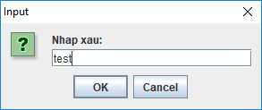 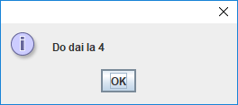

**Assignment 5:**

.data

buffer**:** .space 50

**.text**

li $s6**,** 20 # Max length

li $s7**,** 10 # ASCII code of '\n'

la $s0**,** buffer # Load buffer

li $s1**,** 0 # index **=** 0

li $s3**,** 0 # i **=** 0

start_read_char**:**

li $v0**,** 12

**syscall** # Read char

**add** $s1**,** $s0**,** $s3 # Load buffer**[**i**]**

addi $s3**,** $s3**,** 1 # i**++**

beq $s3**,** $s6**,** end_read_char # exit when max length

beq $v0**,** $s7**,** end_read_char # exit when **enter**

sb $v0**,** 0**(**$s1**)**

j start_read_char

end_read_char**:**

Print_the_reverse_string**:**

li $v0**,** 11

lb $a0**,** 0**(**$s1**)**

**syscall**

beq $s1**,** $s0**,** exit

addi $s1**,** $s1**,** **-**1

j Print_the_reverse_string

exit**:**

**Conclusion:**

Before you pass the laboratory exercise, think about the questions below:

1. *What the difference between the string in C and Java?*

* String in C is Array terminated with a NUL (\0) character. But, in Java strings are instances (objects) of the *java.lang.String* class, you can not use them as array.

1. *In C, with 8 bytes, how many characters that we can store?*

* Chars in C are typically (not always) 8-bit

1. *In Java, with 8 bytes, how many characters that we can store?*

* Java chars are 16-bits (always).